**Lab 0 Report**

**Title:** Comparison of three different environments with performing the same analysis

**Notice:** Dr. Bryan Runck

**Author:** Liang-Ting Chen

**Date:** Feb 3, 2021

**Project Repository:**

<https://github.com/chen6761/GIS5571.git>

**Abstract**

In the lab, I will do the same analysis in three different environments, ArcPro, Jupyter Notebooks in ArcPro, and Jupyter Notebooks in ArcOnline to discuss the difference between them. Each environment has its advantage in the analysis.

**Problem Statement**

There are many methods to do the same analysis via Esri software. I will buffer the road network through ArcPro, Jupyter Notebooks in ArcPro, and Jupyter Notebooks in ArcOnline to compare the difference between. I think the result might be the same, however, the convenience and efficiency of operation might be different.

Table 1. The requirement data

|  |  |  |  |  |  |  |
| --- | --- | --- | --- | --- | --- | --- |
| **#** | **Requirement** | **Defined As** | **Spatial Data** | **Attribute Data** | **Dataset** | **Preparation** |
| 1 | Road network | Raw input dataset | Road geometry |  | MNGeo |  |

**Input Data**

In the lab, I choose the road network in Rice County to present the buffer analysis.

Table 2. The input data

|  |  |  |  |
| --- | --- | --- | --- |
| **#** | **Title** | **Purpose in Analysis** | **Link to Source** |
| 1 | Rice County Roads | Execute the buffer analysis | [MNGeo](https://gisdata.mn.gov/dataset/us-mn-co-rice-trans-roads) |

**Methods**

**ArcPro**

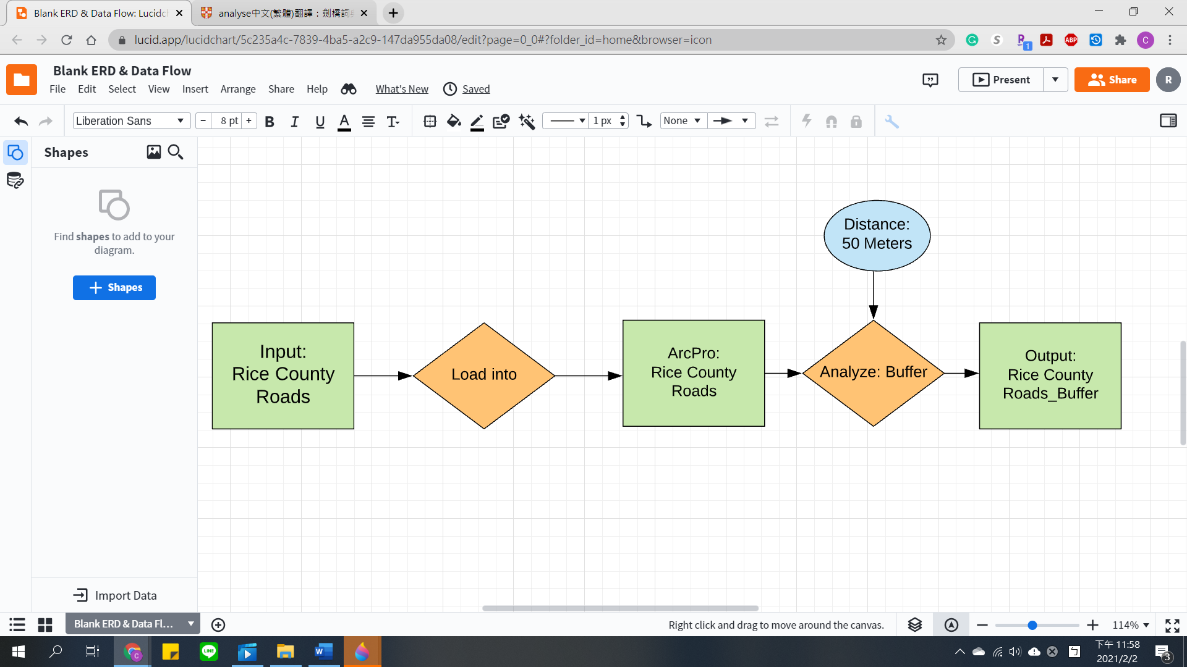

1. Load the Rice County Roads dataset by adding the new folder connection.
2. Execute the buffer under the analysis tab by entering the parameters.

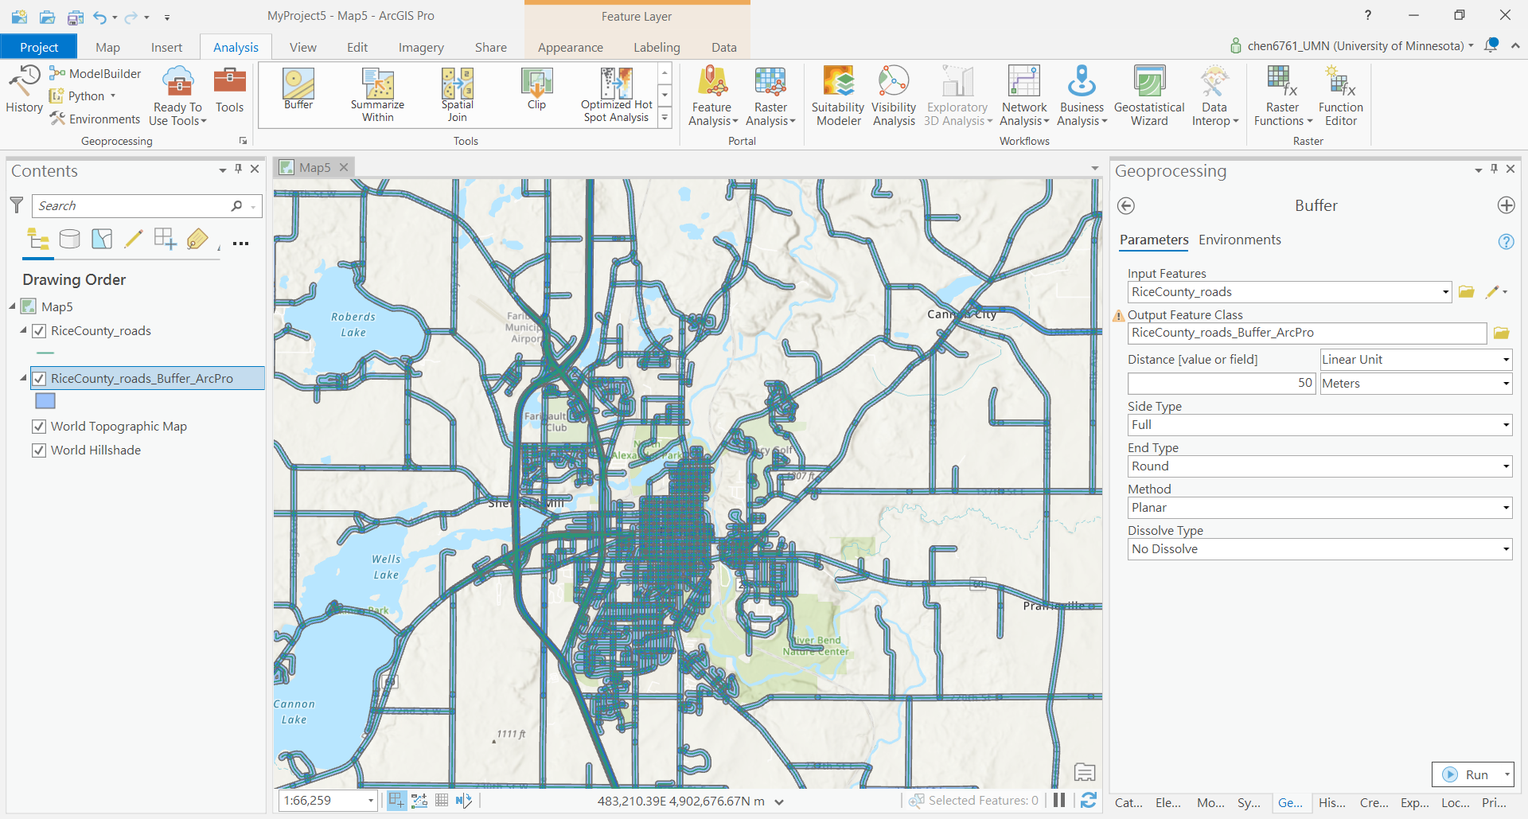

**Jupyter Notebooks in ArcPro**

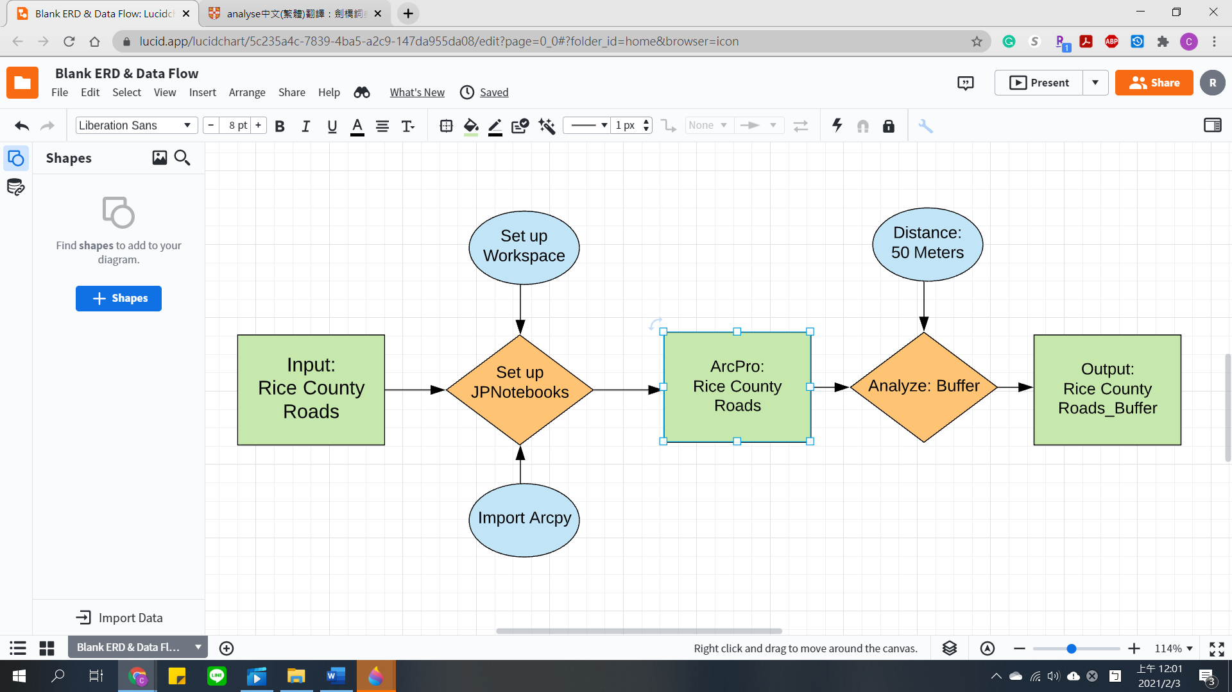

1. Import arcpy functions
2. Set up workspace
3. Execute the buffer analysis (*Buffer (Analysis)—ArcGIS Pro | Documentation*, 2020)

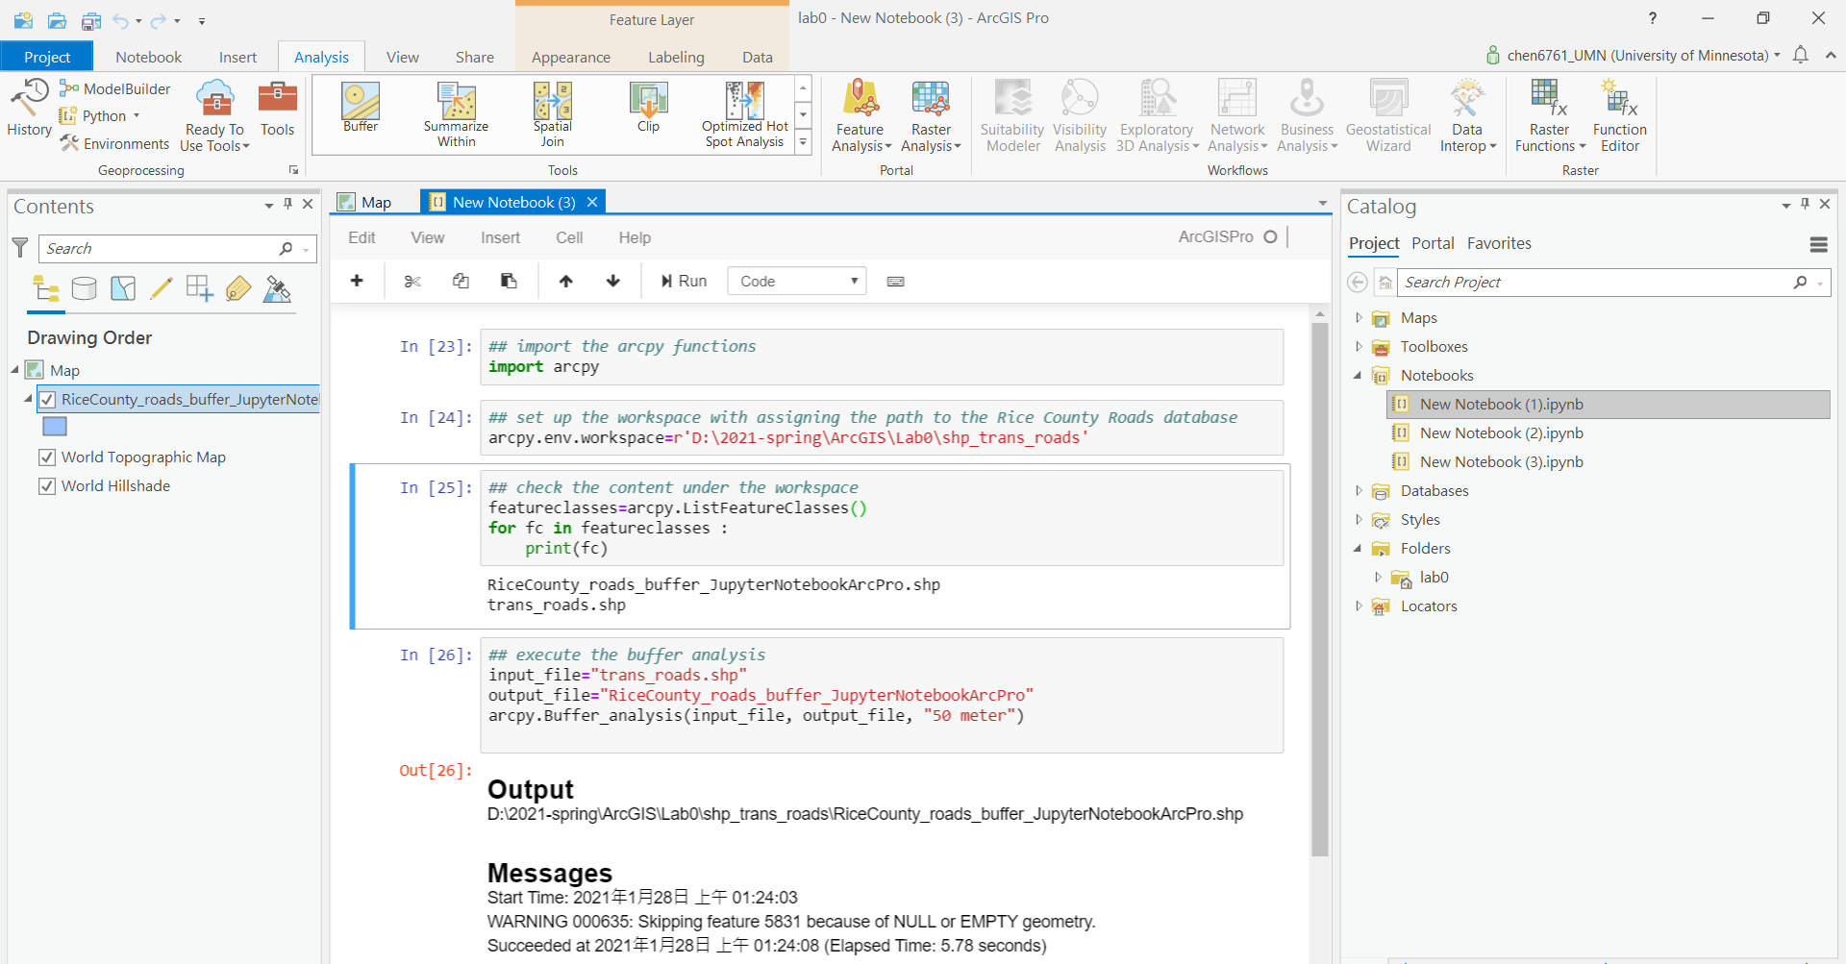

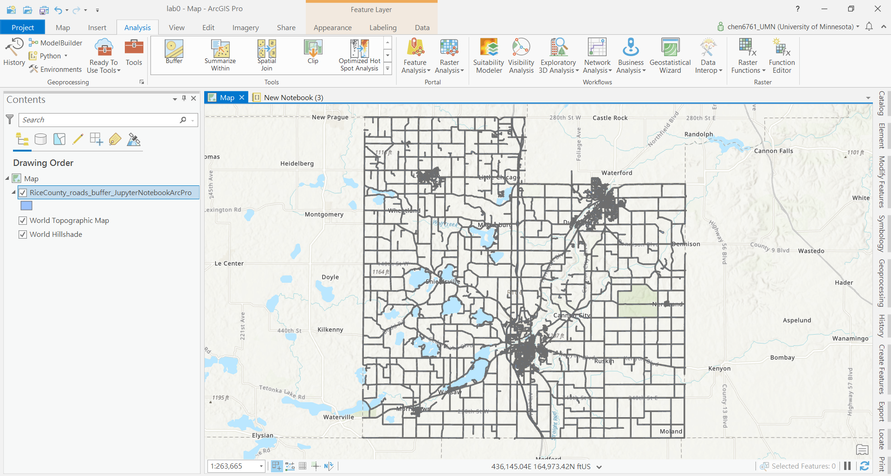

**Jupyter Notebooks in ArcOnline**

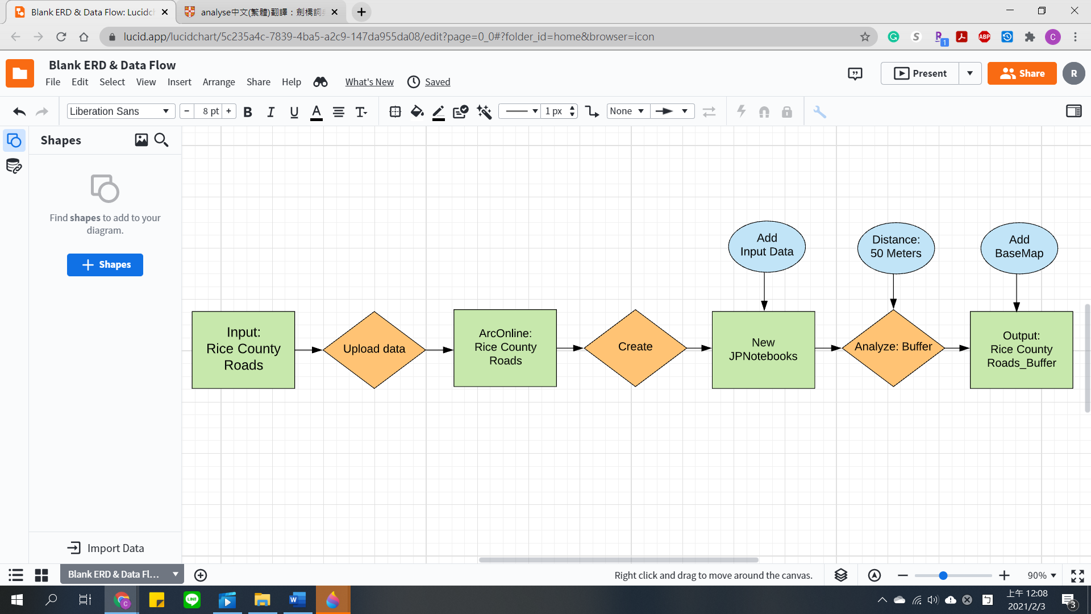

1. Upload the dataset to my ArcOnline content
2. Open a new notebook
3. Add the item from the left side menu
4. Add the buffer analysis from the left side menu
5. Set the parameter and execute (*Proximity Analysis | ArcGIS for Developers*, 2020)

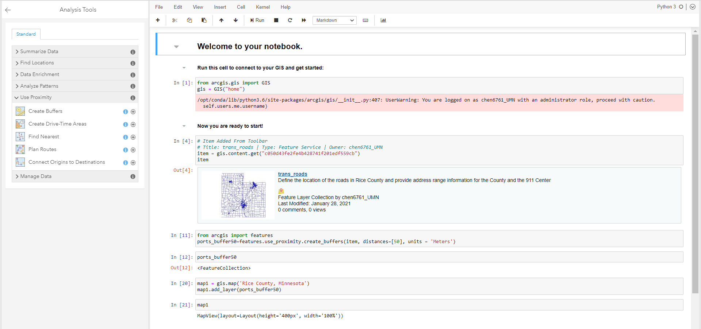

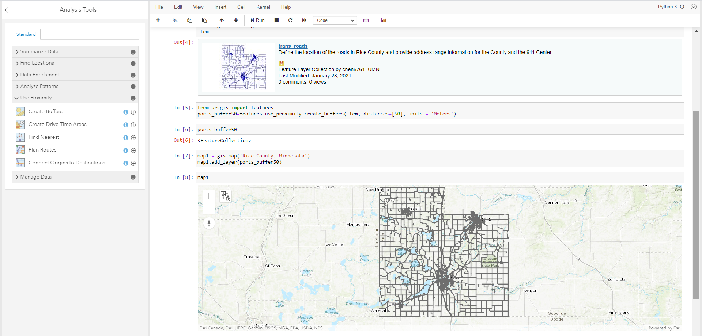

**Results**

|  |  |  |  |  |
| --- | --- | --- | --- | --- |
|  | Intuitive | Efficiency | Shareable | Less Preparation |
| ArcPro | 1 | 2 | 2 | 2 |
| JupyterNBArcPro | 3 | 1 | 1 |
| JupyterNBArcOnline | 2 | 3 | 1 | 3 |

For the intuition, I think the ArcPro is the easiest to use because of its GUI interface. The Jupyter Notebooks in ArcPro is with the highest efficiency of analysis because it can finish all the work with coding. The Jupyter Notebooks in ArcOnline is the easiest one to share the result with others, however, it needs more preparation because users need to upload the dataset first.

**Results Verification**

I set all the buffer analysis with the same parameter, 50 meters. So, I can check my result by examining them on the same kind of map.

**ArcPro**

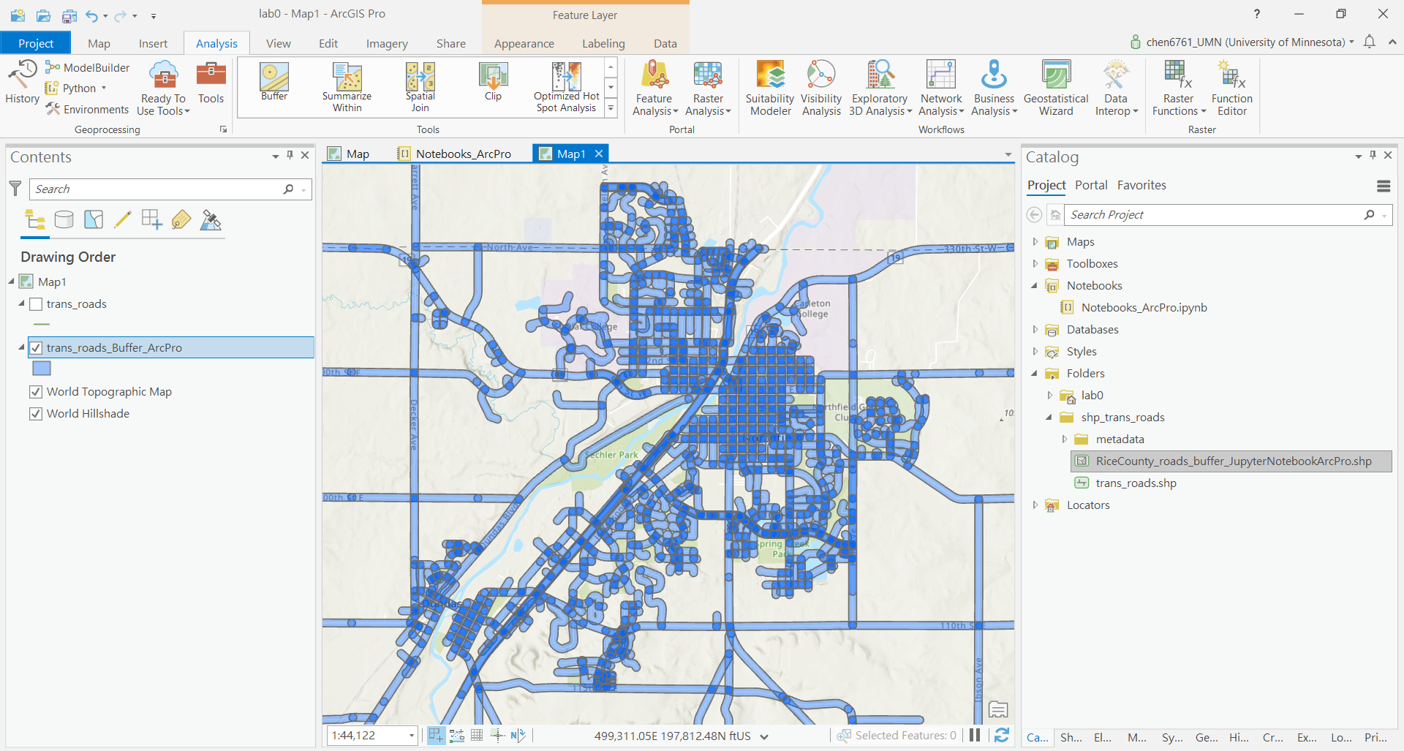

**JupyterNotebook in ArcPro**

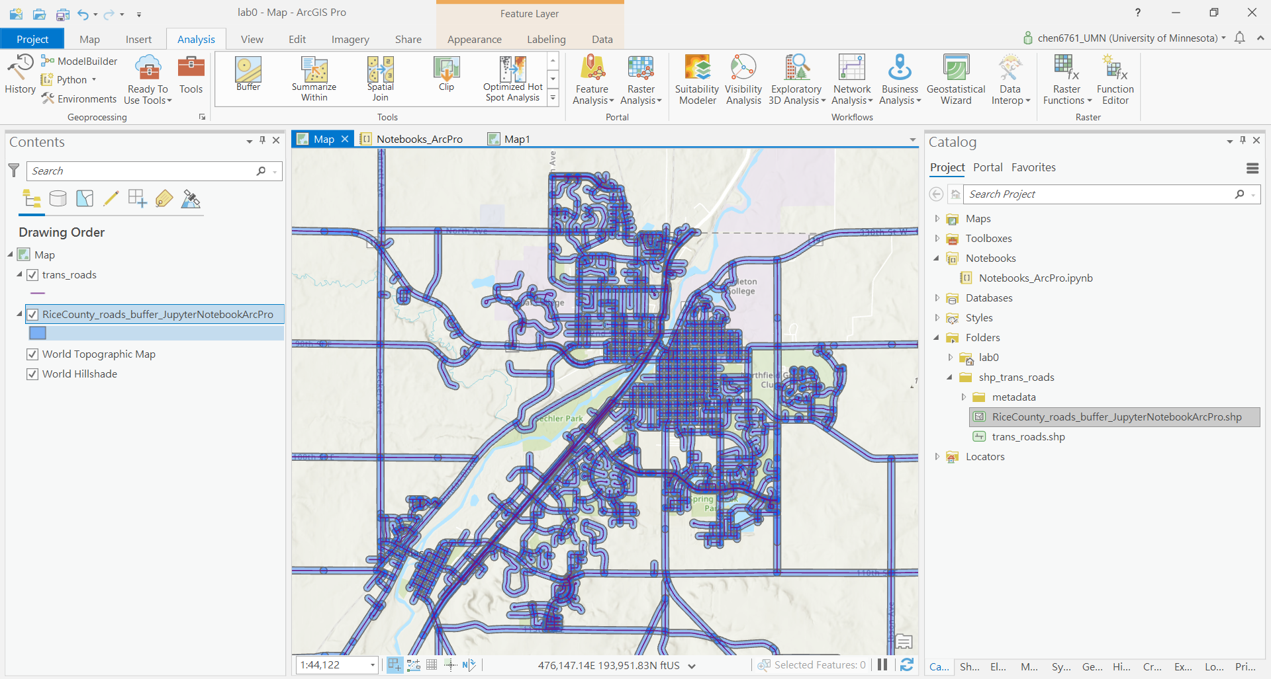

**JupyterNotebook in ArcOnline**

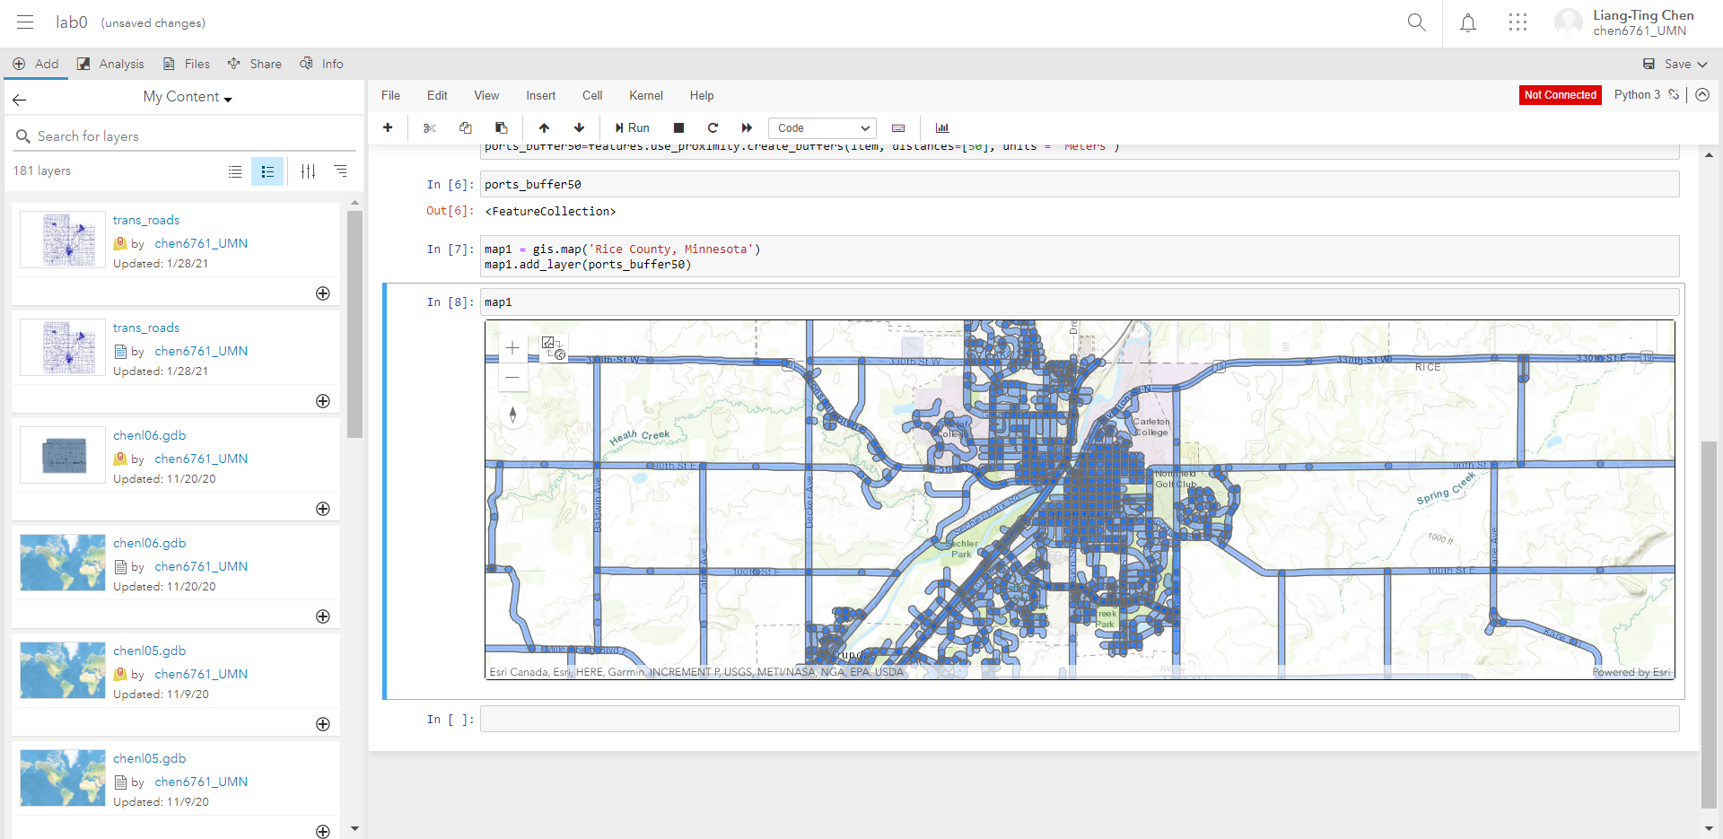

**Discussion and Conclusion**

**Section 1 –** GitHub

It is a good chance for me to review how to work in GitHub. I did not meet problems in this section because I used GitHub to finish the project with my teammate last semester. We used the clone, add, commit, push, request, merge, and pull several times to make sure we did not overlap other’s work by accident.

**Section 2**

I used the ArcPro and Jupyter Notebooks in ArcPro before, and it gave me a chance to review how to use these tools, including setting up the workspace, loading the target shapefile, and executing the analysis. However, it is my first time using Jupyter Notebooks in ArcOnline, but I am glad that I have this opportunity to learn it. I find this environment is between the original Jupyter Notebooks and ArcPro. It can add the codes by clicking the function in the menu, like the GUI interface, however, I need to set the parameters by entering the code, like I used to do in the Jupyter Notebooks. It is a quite new environment for me, but it is helpful for me to make some attributes analysis online.

Overall, I think the best thing for ArcPro is its GUI interface that I do not need to worry about any code error. The advance for the Jupyter Notebooks in ArcPro is that I can easily load the source with few codes and the speed of execution is faster if I am more familiar with the code. The Jupyter Notebooks in ArcOnline is the most convenient one to share my result with other.

**References**

*Buffer (Analysis)—ArcGIS Pro | Documentation*. (2020). Esri. https://pro.arcgis.com/en/pro-app/latest/tool-reference/analysis/buffer.htm

*Proximity analysis | ArcGIS for Developers*. (2020). Esri. https://developers.arcgis.com/python/guide/performing-proximity-analysis-on-feature-data/

**Self-score**

|  |  |  |  |
| --- | --- | --- | --- |
| **Category** | **Description** | **Points Possible** | **Score** |
| **Structural Elements** | All elements of a lab report are included **(2 points each)**:  Title, Notice: Dr. Bryan Runck, Author, Project Repository, Date, Abstract, Problem Statement, Input Data w/ tables, Methods w/ Data, Flow Diagrams, Results, Results Verification, Discussion and Conclusion, References in common format, Self-score | 28 | 28 |
| **Clarity of Content** | Each element above is executed at a professional level so that someone can understand the goal, data, methods, results, and their validity and implications in a 5 minute reading at a cursory-level, and in a 30 minute meeting at a deep level **(12 points)**. There is a clear connection from data to results to discussion and conclusion **(12 points)**. | 24 | 22 |
| **Reproducibility** | Results are completely reproducible by someone with basic GIS training. There is no ambiguity in data flow or rationale for data operations. Every step is documented and justified. | 28 | 26 |
| **Verification** | Results are correct in that they have been verified in comparison to some standard. The standard is clearly stated **(10 points)**, the method of comparison is clearly stated **(5 points)**, and the result of verification is clearly stated **(5 points)**. | 20 | 20 |
|  |  | 100 | 96 |